System Requirements Statement (SRS)

Play Pro Football

|  |  |  |
| --- | --- | --- |
| **1** | **Introduction…………………………………………………………………………………………………** | **3** |
| **2** | **Functional Requirements ……………………………………………………………………...** | **4** |
| **2.1** | **ORGANIZATION Module ……………………………………………………………………………….** |  |
| **2.2** | **Spectator Module ……………………………………………………………………………………..** |  |
| **2.3** | **Admin Module ………………………………………………………………………………………………** |  |
| **3** | **Use Case Diagram …………………………………………………………………………………………** |  |

THIS DOCUMENT CONTAINS XX NUMBERED PAGES

# Introduction

This document explains the system requirements and scope for developing PlayPro Football Tournament Management System.  
  
PlayPro Football is divided into three main parts: Committee part, Spectator part, Admin part.

# 

**2. Functional Requirement**

* **The Account part of PlayPro Football System has three modules which are divided into several processes described as below.**

|  |  |  |
| --- | --- | --- |
| **No** | **BRS requirement ID** | **Description** |
| **2.1** | **Committee Module** | |
| **2.1.1** | **C1** | **Account Creation Process** |
| **2.1.2** | **C2** | **Login Process** |
| **2.1.3** | **C3** | **Update Profile** |
| **2.1.4** | **C4** | **Authenticate players** |
| **2.1.5** | **C5** | **Maintain Player Portfolios** |
| **2.1.6** | **C6** | **Debar Players** |
| **2.1.7** | **C7** | **Plan Tournament** |
| **2.1.8** | **C8** | **Publish Tournament** |
| **2.1.9** | **C9** | **Publish Result** |
| **2.2** | **Spectator Module** | |
| **2.2.1** | **C10** | **Account Creation Process** |
| **2.2.2** | **C11** | **Login Process** |
| **2.2.3** | **C12** | **Update Profile** |
| **2.2.4** | **C13** | **Browse Matches and Tournaments** |
| **2.2.5** | **C14** | **Leave Feedback** |
| **2.3 Admin Module** | | |
| **2.3.1** | **C15** | **Login Process** |
| **2.3.2** | **C16** | **Update Profile** |
| **2.3.3** | **C17** | **Authenticate tournament committees** |
| **2.3.4** | **C18** | **Remove or block committees if necessary** |
| **2.3.5** | **C19** | **Generate reports and analytics** |
| **2.3.6** | **C20** | **Account Management** |

* 1. **Committee Module**
* The Committee module is responsible for managing player authentication, tournament planning, and match execution.
* It handles player portfolios, debars disqualified players, and publishes tournament schedules and results.

1. Account Creation Process

* PlayPro Football System compels to create the account before using it. So, PlayPro Football System should provide the function which makes committee creates new account.
* When committee creates new account, the function demands four information described as below.

1. Login information
2. Contact Details

* The Login information

The Login information consists of some items described as below.

1. UserID
2. Password
3. First Name
4. Last Name
5. E-mail address
6. User Type
   * All items are compulsory demanded.
   * UserID

* The UserID should be unique. If the UserID correspond with not case-sensitive to other which is previously registered, the UserID should not be registered as an account.
  + Password
* The Password has constrains which makes the Password consists of more than or equal 8 and less than or equal 16 characteristics including characters described as below.

1. Numeric figure (at least one)
2. Capital alphabet (A-Z)(at least one)
3. Small alphabet (a-z)(at least one)
4. Special character (#, $, %, &, etc.) (at least one)

* The Password is masked by dummy characters. The re-entering Password is demanded.
* The Password must be encrypted in e-Farming System.
  + User Type

The User Type falls into three categories described as below.

1. Committee
2. Spectator
3. Administrator

* The User Type defines also three types of user; "Committee user", "Spectator user", and "Administrator user”.
* In an Account Creation Process, the user can select Committee.
* No one could select The Administrator, because Administrator is implemented to PlayPro Football System in advance.
* Contact Details
* The Contact Detail consists of some items described as below.

1. Permanent Address
2. Contact Phone No
   * All items are compulsory demanded.
   * Permanent Address

* Permanent Address should be filled.
* But only the state should be selected from options.
* The Security Question information

The Security Question information is needed when farmer lost their Password. This information consists of two items described as below.

1. Selected Question
2. Answer
   * All items are compulsory demanded.
   * Some questions which are difficult to answer for anyone else are prepared in advance.

E.g. which color do you like most?

* A question should be selected from options by the committee, and the Answer is registered by the committee.
* Login information should be entered on one screen, and then committee information and Security Question information should be entered on another screen.

### Login Process

* PlayPro Football System always compels user authentication before using itself except when a new account is successfully created.
* The user authentication demands UserID and Password. The UserID and the Password should be checked in three ways.
* First, The UserID and the Password should be existed and correct.
* If The UserID and the Password are not equal to what the user has registered, the user authentication cannot be provided.
* Second, the User Type linked to the UserID should be "committee".
* When the User Type is "Committee", then user can be placed on “Committee Home”.
* Finally, UserID should be available.
* The Administrator can decide whether the UserID is available or suspended – Refer to the SRS of the Admin part.
* If committee is rejected, user authentication is not provided for system user.
* The committee account should alive for so long as the duration decided by Admin.
* Only when the three checks are successfully completed, committee can be placed on respected page.
* The “Committee Home” provides the some items described as below.

1. A trigger to logout
2. A trigger to update Account
3. A trigger to Change Password
4. A trigger to Search Match or Tournament Info
5. A trigger to Publish Match or Tournament Info for feedback or stats
6. A trigger to Update Match or Tournament Info Information
7. A trigger to Delete Match or Tournament Info
8. A trigger to Browse existing Market price

### Forgot Password Process

* When system user lost their Password, the recovery method should be provided by PlayPro Football system.

The recovery method is described as below.

* First, system user enters their UserID for PlayPro Football System.
* Next, PlayPro Football System demands the Answer which has been registered since when the Account was created.
* Only when the Answer is correct, committee get the new password by E-mail which also has been registered since when the Account was created.
* The new password is automatically generated by PlayPro Football System.
* Of course, the new password should consist of more than or equal 8 and less than or equal 16 characteristics including at least a numeric figure, a capital alphabet, a small alphabet, and a special character.
* As a consequence, The Committee could get the committee authentication using the new password.
* Then, the committee had better change the new password manually.
* If the Answer is not correct, otherwise, the correct Answer is demanded for user again.
* In that case, Of course, committee couldn’t get the new password.

### Change Password Process

* When committee wants to change their Password, the measure should be provided by PlayPro Football System.
* Therefore, PlayPro Football System should provide the function which is available after getting the committee authentication.
* The function demands the current password and the new password.
* Of course, the new password should consist of more than or equal 8 and less than or equal 16 characteristics including at least a numeric figure, a capital alphabet, a small alphabet, and a special character.
* The current password and the new password are masked by using dummy characters.
* The new password is demanded to enter twice to avoid a typing error.
* Only when the current password is correct, committee could change their Password.
* When the current password is changed into new password, PlayPro Football System compels user authentication again.

### Update Account Process

* PlayPro Football System should provide the function which makes the account updated for committee.
* The information committee could update is described below.

1. Login information
2. User information
3. Security Question Information

* The Login information
* The updatable items as described below.

1. First Name
2. Last Name
3. E-mail address

* All items are compulsory demanded, but updating is optional.
* The User information
* The updatable items as described below.

1. User Name
2. User Phone No
3. E-mail address
4. Permanent address

* All items are compulsory demanded, but updating is optional.
* The Security Question information
* The updatable items as described below.

1. Selected Question
2. Answer
   * All items are compulsory demanded, but updating is optional.

### Search match or tournament info

* Search conditions are described as below.
* Match or Tournament Info category
* Price range

### Publish match or tournament info for feedback or stats

* Publish match or tournament infos requirements are described as below.
* Match or Tournament Info category
* Price
* Match or Tournament Info name
* Quantity
* Photos

Committee can see match statistics before publishing match or tournament infos.

### Update match or tournament info information

* After publishing the match or tournament info the committee can only update following contents.
* Match or Tournament Info quantity
* Match or Tournament Info price.

### Delete match or tournament info information

• After Publishing if committee wants to remove some match or tournament infos then he can delete the match or tournament info.

### Browse existing match or tournament info Price

• Committee could see the information of existing match or tournament infos.

#### 2.5 Use Case Diagram

**Committe**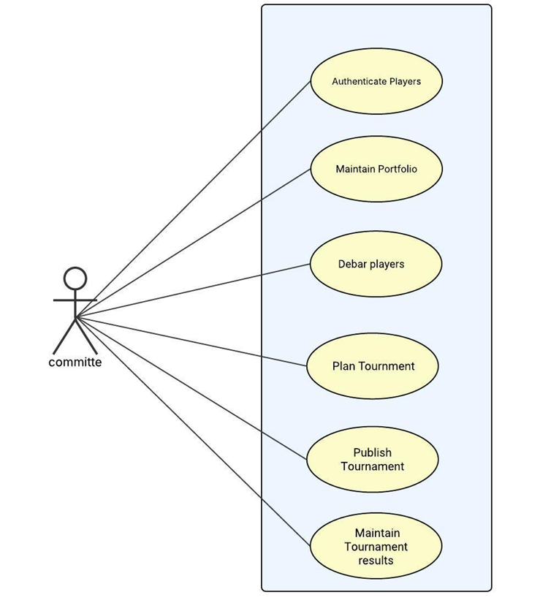

*Fig. Use case diagram for committee*

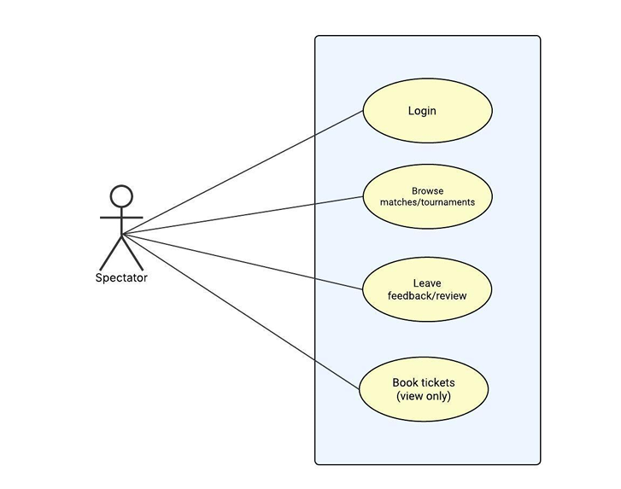

*Fig. Use case diagram for Spectator*

**Admin:**

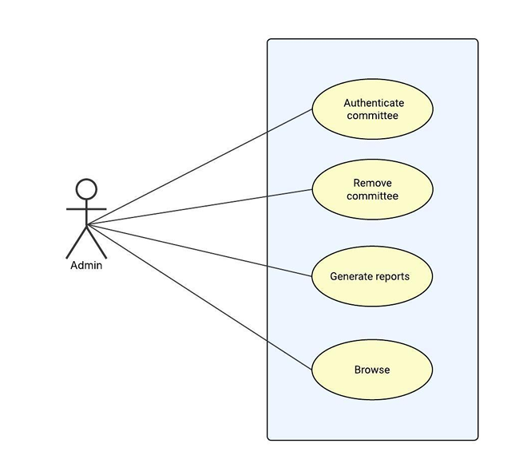

*Fig. Use case diagram for Admin*